
SHIRE HIGHLANDS EDUCATION DIVISION
2026 MALAWI SCHOOL CERTIFICATE OF EDUCATION MOCK
EXAMINATION
PHYSICS
Subject Number: M161/I
Monday, 23 March TimeAllowed: 2 hours
8:00 - 10:00 am
PAPER I
(100 marks)

THEORY

Instructions
- This paper contains 10 printed pages. Please check.

- Fill in your name and name of your School at the top of each page.

- This paper contains two sections, A and B. In Section A there are short answer questions while Section B there are restricted essay questions.

- Use of electronic calculators is allowed.

- The maximum number of marks for each answer is indicated against each question.

- In the table provided on this page, tick against the number of question you have answered.

- Hand in your question paper to the invigilator when time is called to stop writing.

Question Number | Tick if  answered | Do not write in these columns
1
2
3
4
5
6
7
8
9
10
11
12
13

© 2026 SHED MOCK Turn over

Section A (70 Marks)
1(a) State the work – energy theorem.
_________________________________________________________________________________________________________________________________________(1mark)
(b) Figure 1 is a carbon resistor with its colour code as shown in table 1
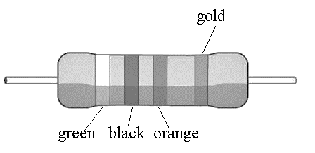
Figure 1
Table 1
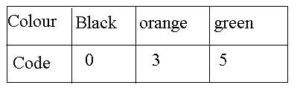
Tolerance $± 5\%$
- Calculate the resistance of the resistor in figure 1

( 3 marks)
- State the effect of increasing temperature on tolerance of resistor in figure 1
______________________________________________________________________________________________________________________________________________________________________________________( 1 mark)

(c) Figure 2 shows a load against extension graph of spring.
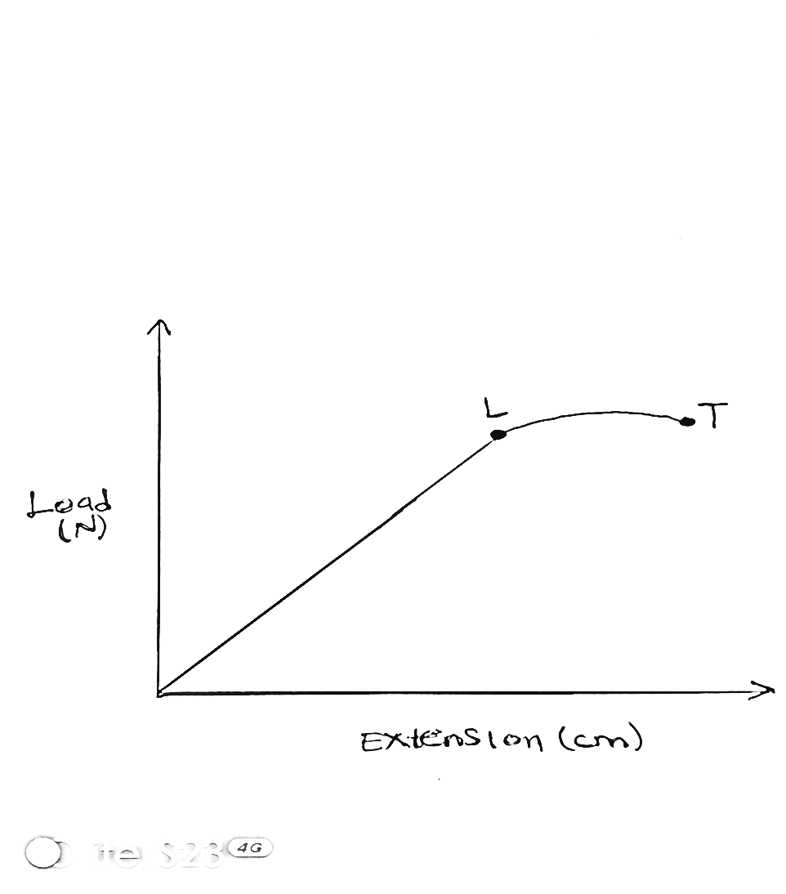
Figure 2
- Name the following parts as indicated in the graph
Point L__________________________________________________________(1mark)
Section LT________________________________________________________(1mark)
- State the law that describes the property of a spring.
_________________________________________________________________________________________________________________________________________(1mark)
- a. Give any two ways of focussing an object in a simple lens camera.
________________________________________________________________________________________________________________________________________(2marks)
- Figure 3 shows two separate waves propagating in a medium.
A
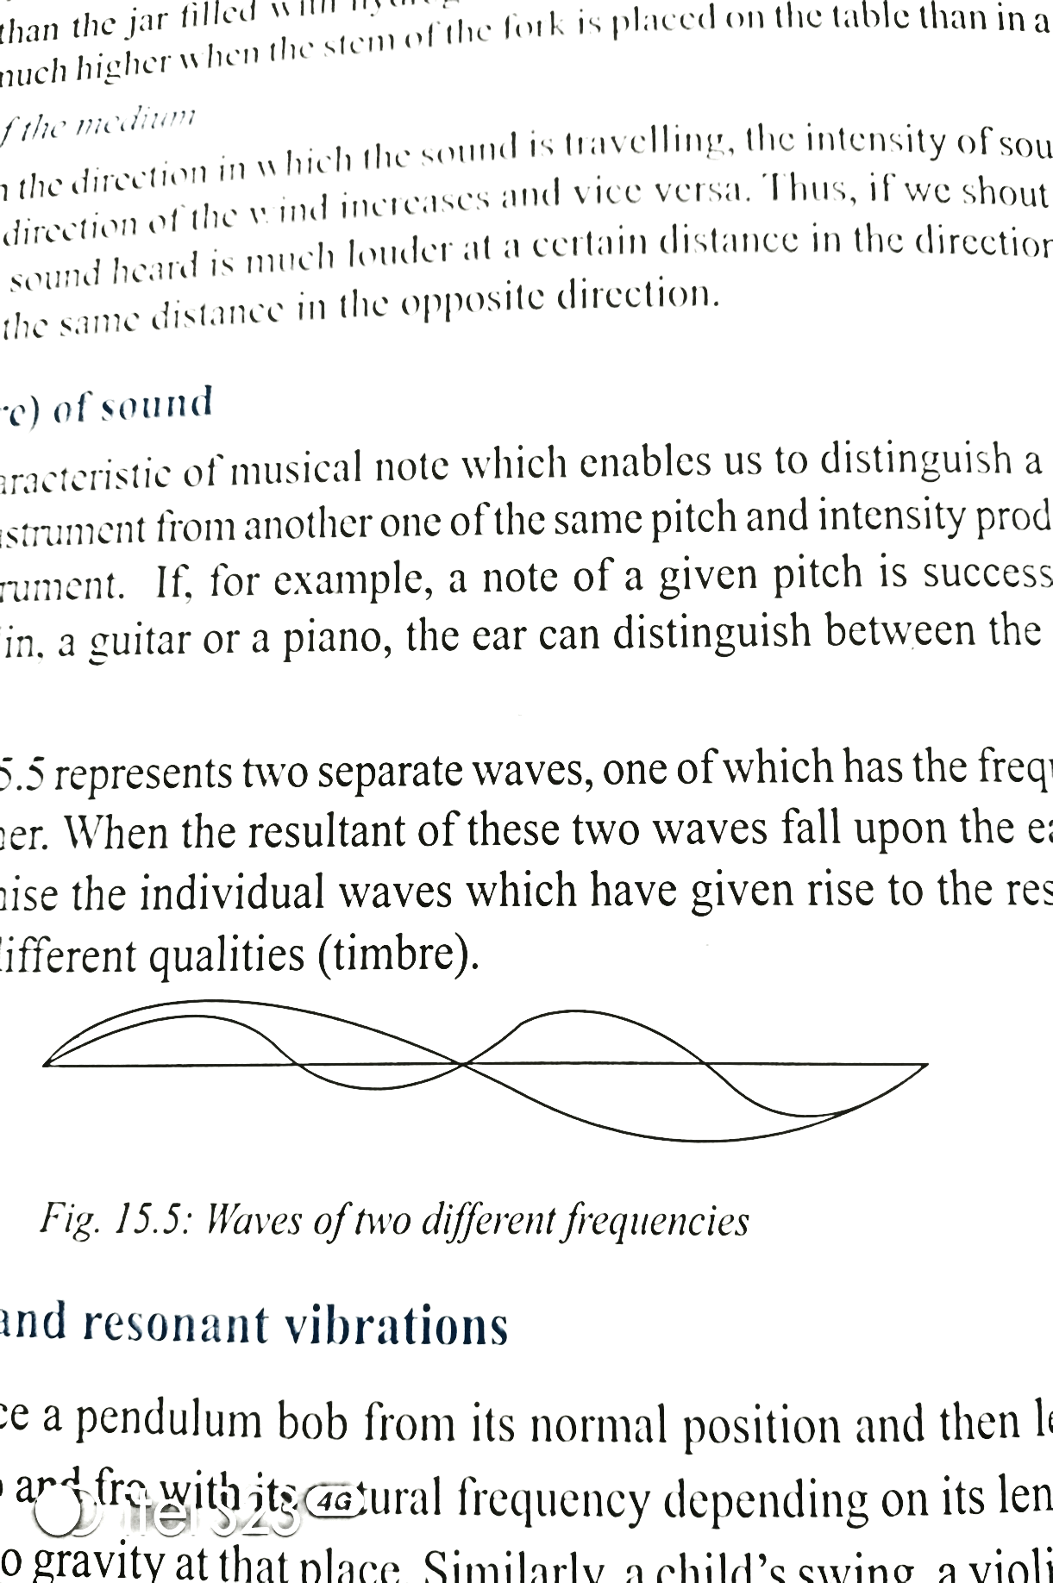
Figure 3 B

- What type of waves are shown in figure 3?
________________________________________________________________(1mark)

- Which wave has the highest frequency?
________________________________________________________________(1mark)
- Give a reason for your answer to 2a(ii).
_________________________________________________________________(1mark)
- Describe the working of a convex lens on a long sighted person.
________________________________________________________________________________________________________________________________________________________________________________________________________________________________________________________________________________________(4marks)
- a. Give any one difference between radioactivity and nuclear radiation.
__________________________________________________________________
_____________________________________________________________________________________________________________________________(1mark)
- Describe how X-Rays are used to detect a fracture in a bone.
______________________________________________________________________________________________________________________________________________________________________________________________(3marks)
- Give any two factors that affect the intensity of sound waves.
____________________________________________________________________________________________________________________________(2marks)
4 a. State any one relationship between mechanical advantage of a machine and its efficiency.
_____________________________________________________________________________________________________________________________(1mark)
b. Calculate the acceleration of an object which moves from rest and reaches a speed of 5m/s in 2 seconds in a straight line. (3marks)

c. c. Give any two factors that affect gas pressure.
_____________________________________________________________________________________________________________________________________(2marks)
- a. Figure 4 shows an electric component.
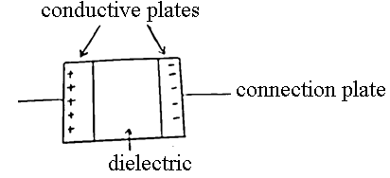
Figure 4

- Name the component.
___________________________________________________________(1mark)
- Give any two ways of increasing the performance of the component in figure 3.
_____________________________________________________________________________________________________________________________(2marks)

b. Calculate the cost of heating water using a 1.5Kw heater switched on for 30 minutes if the cost of electricity is K140.00 per unit.

(3marks)

- a. Figure 5 shows how the diameter of a wood block was measured.
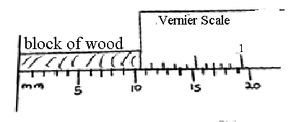
Figure 5

- Name the measuring instrument which was used to obtain this diameter.
___________________________________________________________(1mark)
- Calculate the diameter of the block if the Least Count (LC) is 0.1mm.

(3

(3marks)
(b) State any two ways of reducing parallax errors in an experiment.
________________________________________________________________________________________________________________________________________(2marks)
c. Give the two types of nuclear reactions.
_______________________________________________________________________________________________________________________________________( 2marks)
- a. State any one difference between analogue and digital circuits.
______________________________________________________________________________________________________________________________________________________________________________________________________(2marks)
b. Define the term Zener effect.
_____________________________________________________________________________________________________________________________(1mark)
c. Explain the leakage of flux in a transformer leading to energy loss.
________________________________________________________________________________________________________________________________________________________________________________________________________________________________________________________________________________________(3marks)
- a. Explain boat rowing according to Newton’s third law of motion.
______________________________________________________________________________________________________________________________________________________________________________________________________________________________________________________________________________________________________________________________________________________________(3 marks)
b. Calculate the recoiling velocity of a 5Kg rifle which fires a bullet of mass 0.02Kg and travels at a velocity of 400m/s.

(4marks)
- Figure 6 below is a diagram of a lever system.
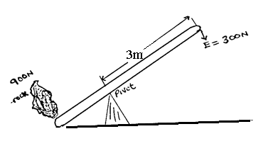
Figure 6
- Name the lever.
___________________________________________________________(1mark)

- Calculate the distance between the pivot and the rock. ( 3 mark)

- Give any two examples of distance multipliers.
________________________________________________________________________________________________________________________________________(2marks)
10. a. Define the term ‘vector resolution’
_________________________________________________________________________________________________________________________________________(1mark)
b. Describe how the triangle rule can be used to determine the resultant of two forces acting at angle using scale drawing.
________________________________________________________________________________________________________________________________________________________________________________________________________________(3marks)
c. Calculate the position of an image of an object standing 8.0cm from the lens of focal length 4.0cm.

(4marks)
Section B (30 Marks)

11.a. With the aid of a well-labelled diagram, describe how a thermocouple thermometer works

________________________________________________________________________________________________________________________________________________________________________________________________________________________________________________________________________________________________________________________________________________________________________________________________________________________________________________________________________________________________________________________________________________________________________________________________________________________________________________________________________________________________________________________________________(6 marks)
(b). Explain how Charles Law is applied in flying hot air balloons.
_______________________________________________________________________________________________________________________________________________________________________________________________________________________________________________________________________________________________________________________________________________________________________________________________________________________________________________________________________________________________________________________________________________________________________________________________________________________________________________________________________________________________________________________________________________________________________________________________________________________________________________________________________________________(4 marks)
12.(a). Describe how a spin drier works to dry clothes using the knowledge of circular motion.
________________________________________________________________________________________________________________________________________________________________________________________________________________________________________________________________________________________________________________________________________________________________________________________________________________________________________________________________________________________________________________________________________________________________________________________________________________________________________________________________________________________________________________________________________________________________________________________________________________________________________________________________________________________(5marks)
(b). Explain in terms of band theory why insulators do not conduct electricity even after increasing their temperature.
________________________________________________________________________________________________________________________________________________________________________________________________________________________________________________________________________________________________________________________________________________________________________________________________________________________________________________________________________________________________________________________________________________________________________________________________________________________________________________________________________________________________________________________________________________________________________________________________________________________________________________________________________________________________________________________________________________________________________________________________________________________________________________________________________________________________________________________________________________________________________________________(5marks)
13. (a). Using a vector diagram, describe how a vector can be represented on paper.

______________________________________________________________________________________________________________________________________________________________________________________________________________________________________________________________________________________________________________________________________________________________________________________________________________________________________________________________________________________________________________________________________________________________________________________(4marks)
(b). Explain the use of thermal expansion in tooth filling process.
________________________________________________________________________________________________________________________________________________________________________________________________________________________________________________________________________________________________________________________________________________________________________________________________________________________________________________________________________________________________________________________________________________________________________________________________________________________________________________________________________________________________________________________________________________________________________________________________________________________________________________________________________________________________________________________________________________________________________________________________________________________________________________________________________________________________________________(6marks)

END OF QUESTIONS

